**CA326 Year 3 Project**

**User Manual**

**Dylan Sloyan - 16511419**

**Samuel Wood - 16476066**

**Life Logging Application**

**Table of contents**

1. **Introduction**
2. **Log in**
3. **Sign up**
4. **Home Page**
5. **Camera**
6. **Location**
7. **Step Counter**
8. **Sign out**

**1. Introduction**

Welcome to the Life Logging user manual. The following content has been specifically designed to adhere for first time users of the application. The manual may be read by any user as all users will have the same access to the documented features that the application has to provide.

**2. Log in**

When the user selects the app icon from their device’s home page, the Login page of the app is launched. This consists of two text boxes a Login button and a Sign up option if the user has not already registered an account with the application. The text boxes are for the email that corresponds to the users account and their chosen password (as the icons and hints suggest).

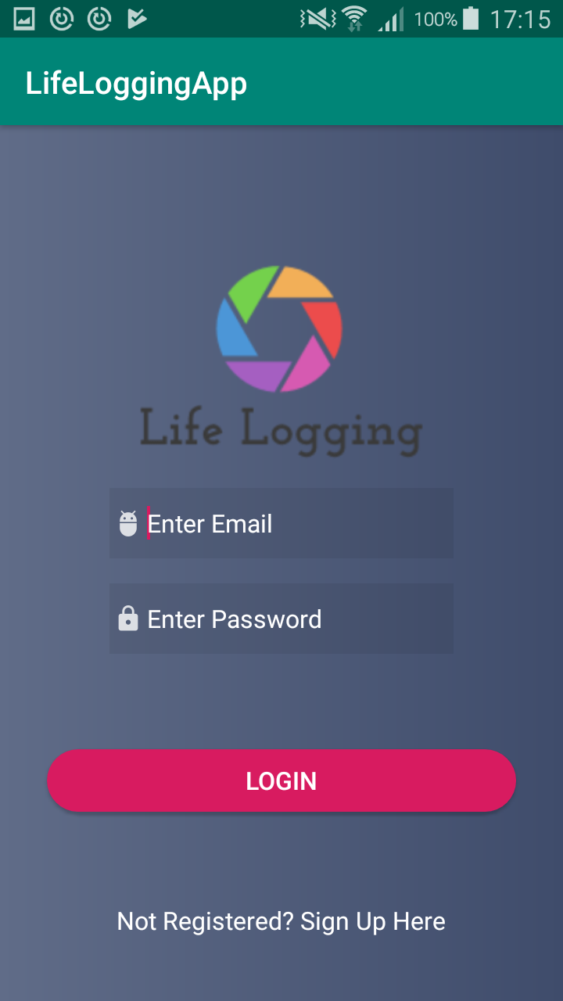 **Fig 2.1 Login screen**

The user will be prompted by validations to re-enter a valid email address should the initial email be invalid. A false password will also ask the user to re-enter a valid one.

**3. Sign up**

Very similar to the Login screen, on this page of the application there are two text boxes where the user can enter their Email and password to create their Life Logging account. There is a password strength requirement of 6 characters at least for the password to be accepted.

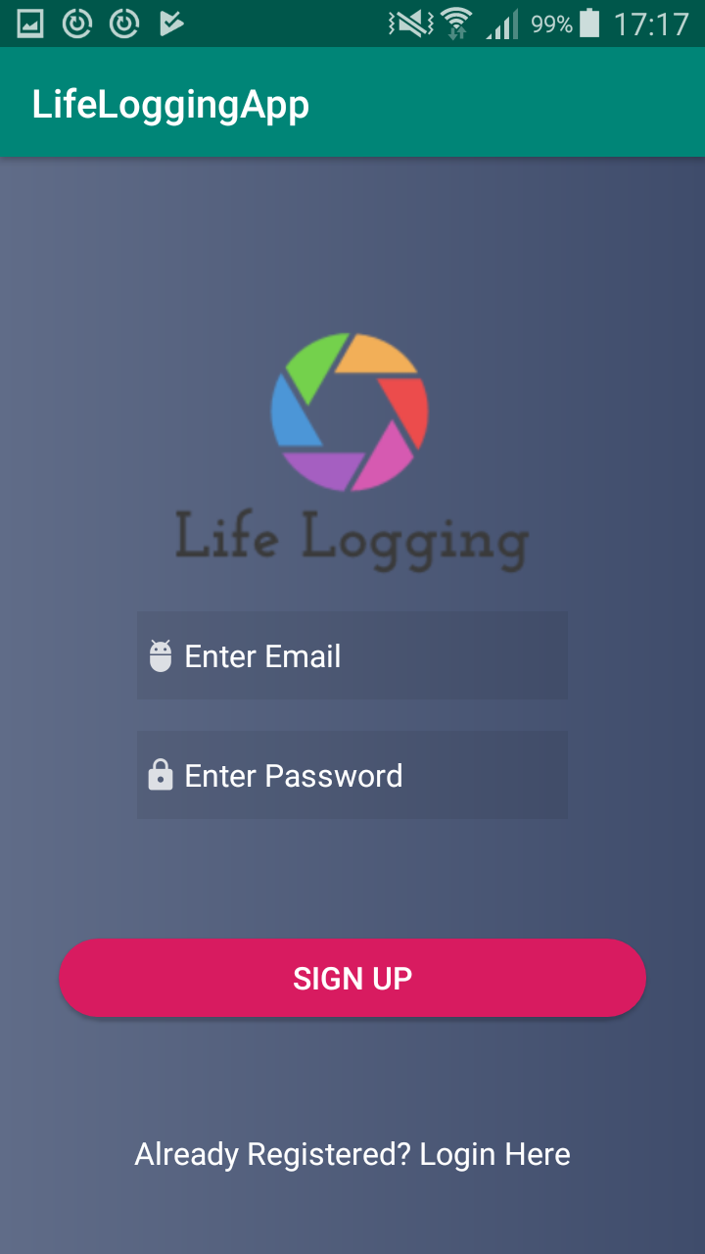 **Fig 3.1 Sign up**

Upon successful sign up the user will be brought to the applications home page. Email and password validations are also provided similar to the login page.

**4. Home page**

